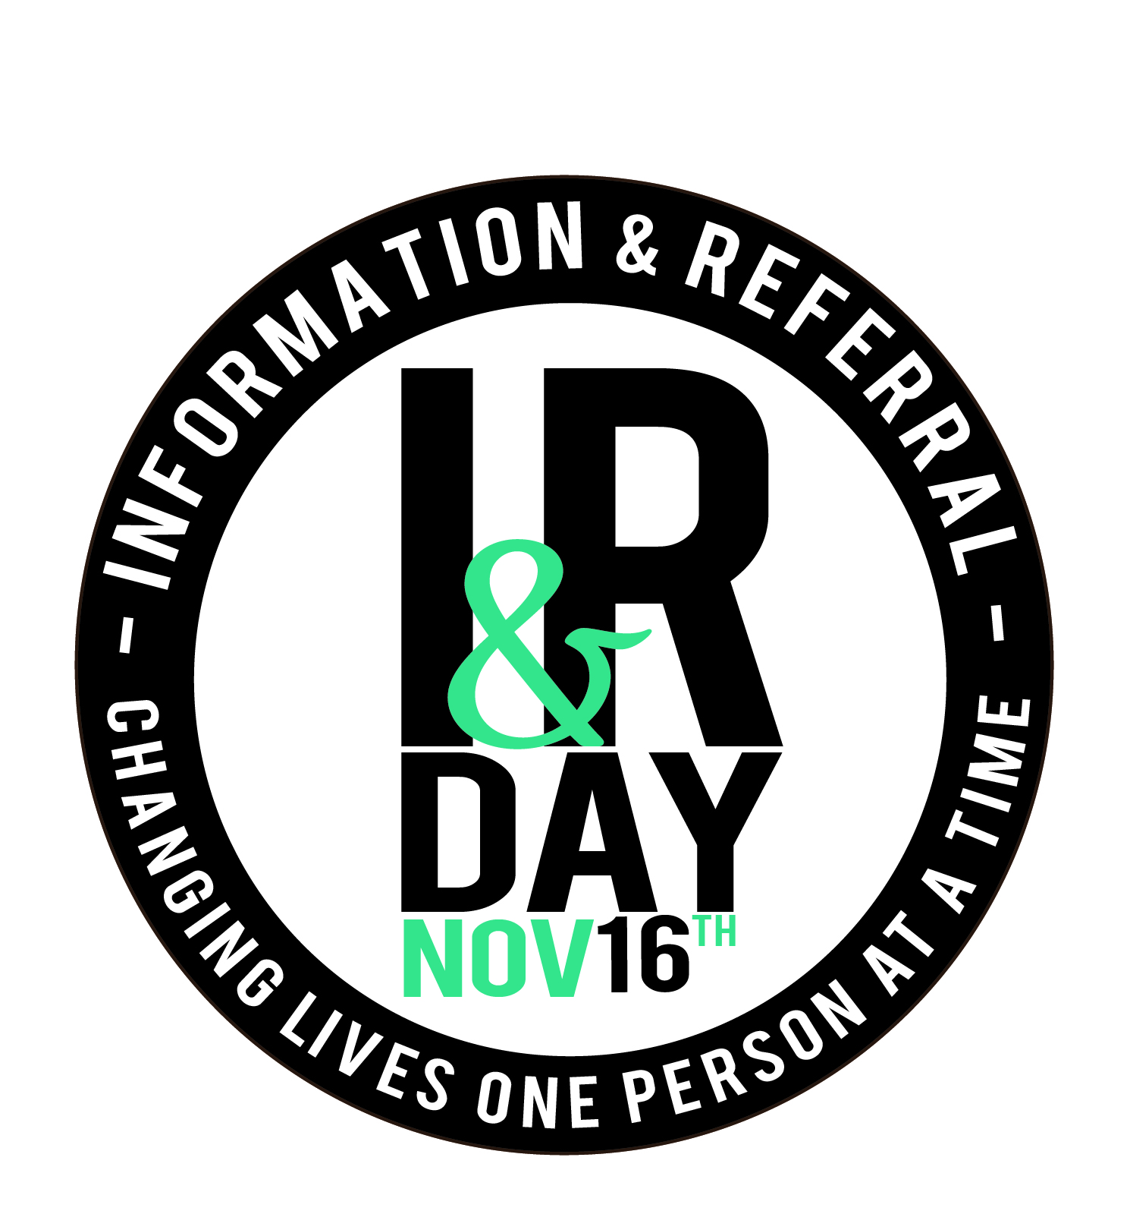

CELEBRATE "I&R DAY" IN YOUR COMMUNITY
November 16th is I&R Day in Ontario
(as declared by InformOntario)

This is your opportunity to celebrate your success stories and raise public awareness of the critical and rigorous work of I&R organizations – both big and small. We know that every day thousands of people find the help they need quickly, conveniently, and free of charge because of Information and Referral (I&R) services throughout Ontario.

To celebrate the work of our sector, InformOntario, its members and partners are celebrating the work they do on November 16th - I&R Day! Here are some ways to celebrate your important role in your community.
- Use social media as a countdown to I&R Day to your community; challenge others to follow your account and share with others
- Ask your local municipal government to declare Nov 16th I&R Day
- Ask your local newspaper or television station to run a story about your local successes
- Host a virtual information fair for the community; invite your local data and I& partners to participate
- Spread the word to your local data and I& partners to also celebrate the day
- Ask a local “celebrity” (mayor, councillor, journalist, president of InformOntario etc) to answer inquiries (create a video for posting; pictures for your website, etc)
- Use the I&R Day logo on press releases, promo materials, buttons, etc.
November 16th was declared I&R Day in the U.S. at the request of AIRS, the Alliance of Information and Referral Systems, an international non-profit professional association of individual, public and private I&R organizational members. InformOntario wants to bring its own flavour to the day by supporting its members. Below are some tools and materials to help your agency quickly create an event for I&R Day.

We are here to support you and we also want hear about and see your event. Please register you r event detail on our website and send us picture and stories so that we can share with other members and collectively build this initiative. https://www.informontario.on.ca/i-r-day-ontario-and-beyond

InformOntario
Email: info@informontario.on.ca

Resource Tools
Donation letter for Business
Community Partner invitation letter
Logo

Date

Business name,
Address,
City, ON PC

Dear business contact,

Information _________ is hosting an event on I&R Day, November 16th, to raise awareness of the important work we do providing information and referrals to the people of ___________ each day.

We hope you will consider donating a gift certificate of $XX to be featured as part of a prize to be won at our event. Your donation of a gift certificate would be added to package of donations by local businesses and services.

Every day thousands of people find the help they need quickly, conveniently, and free of charge because of Information and Referral (I&R) services like ours. People in search of critical services such as financial assistance, food, shelter, child care, jobs, or mental health support often do not know where to begin. With I&R, looking for help means a single phone call or online search. I&R connects people with the services they need. It enables people to participate more fully in the life of their community.

Our event is for anyone who wants to know how to find community services in _______________ and for those who provide those programs and services. XX other organizations will join us and we expect many members of the public to attend.

Your generous donation would help to make our event a success and would be recognized by more than xx participants we expect in attendance. For more information, please see our event website, or feel free to contact me.

Thank you and I look forward to hearing from you!

Warm regards,

November 16th was declared I&R Day in the U.S. at the request of AIRS, the Alliance of Information and Referral Systems, an international non-profit professional association with more than 5,000 individual, public and private I&R organizational members. AIRS is the international voice of I&R and works to improve access to services for individuals, families, and communities by providing professional standards and training for all I&R providers. As an AIRS member, Information ___________ hopes to raise public awareness of the critical and rigorous work of I&R organizations.
Date

Dear Information & Referral partner,

Every day thousands of people find the help they need quickly, conveniently, and free of charge because of Information and Referral (I&R) services like yours.

November 16th is I&R Day! Please join ______________ to celebrate the work we do in our communities!

As a key Information and Referral (I&R) provider in our community we invite you to join us in the celebration and be highlighted for the I&R work you provide. We'd like to offer your organization a table at the event to display information about your services. Due to limited space, the opportunity to have a display table is by invitation only and is limited to approximately 15 organizations who feature I&R as one of their main services.

The event details are as follows:

November 16th is I&R Day!
Presented by __________
Time:
Adress
Event info: Guest speaker, refreshments, invitation to the public.
Please r.s.v.p. by November 2nd.

We hope you’re able to join us for the event. For more information, please call ____________________________

Thank you and I look forward to hearing from you!

Warm regards,

November 16th was declared I&R Day in the U.S. at the request of AIRS, the Alliance of Information and Referral Systems, an international non-profit professional association with more than 5,000 individual, public and private I&R organizational members. AIRS is the international voice of I&R and works to improve access to services for individuals, families, and communities by providing professional standards and training for all I&R providers. As an AIRS member, ________________________ hopes to raise public awareness of the critical and rigorous work of I&R organizations.

